Connected and Disconnected Regions

Definition
# Source: AI Source: Provided by: [Data Path: Persons Table -> ID Column: 1, Name_En Column: Motasem Essam] -> From: [ChatGPT] on [7/25/2026]
In solid geometry, connected and disconnected regions describe whether a region of three-dimensional space forms one continuous piece or consists of separate pieces.
A connected region is a region in which any two points can be joined by a continuous path that stays entirely within the region.
A disconnected region consists of separate parts that cannot all be joined to one another by paths contained entirely within the region.
These concepts apply to the interiors of solids, the solids themselves, and more general regions of three-dimensional space. They are independent of whether a region is bounded or unbounded.
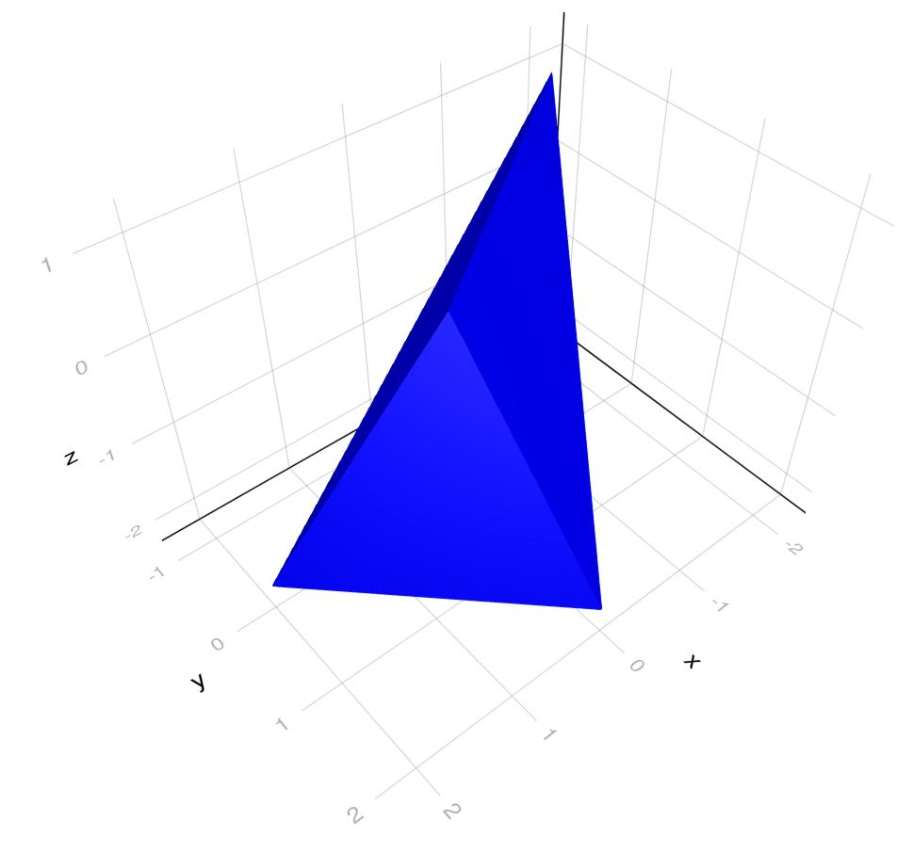
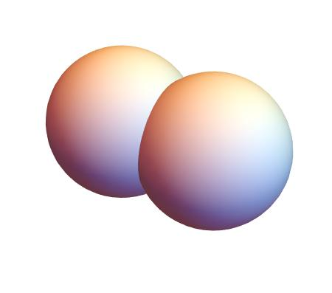
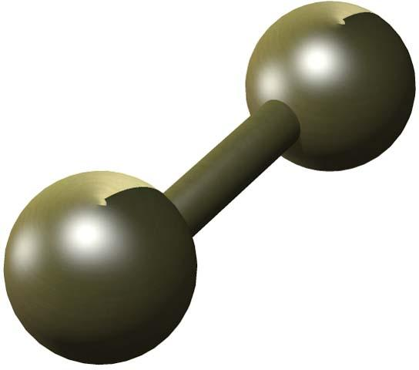

Simple Definition
# Source: AI Source: Provided by: [Data Path: Persons Table -> ID Column: 1, Name_En Column: Motasem Essam] -> From: [ChatGPT] on [7/25/2026]
- Connected region: One continuous piece of space, where you can travel from any point to any other point without leaving the region.
- Disconnected region: Two or more separated pieces of space, where no continuous path within the region connects points in different pieces.
For example, the interior of a solid cube is connected. Two separate solid balls, with a gap between them, form a disconnected region when considered together.

Key Characteristics
# Source: AI Source: Provided by: [Data Path: Persons Table -> ID Column: 1, Name_En Column: Motasem Essam] -> From: [ChatGPT] on [7/25/2026]
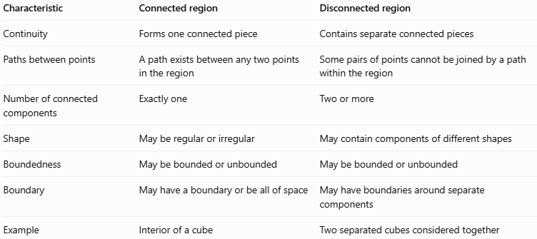
Characteristic | Connected region | Disconnected region
Continuity | Forms one connected piece | Contains separate connected pieces
Paths between points | A path exists between any two points in the region | Some pairs of points cannot be joined by a path within the region
Number of connected components | Exactly one | Two or more
Shape | May be regular or irregular | May contain components of different shapes
Boundedness | May be bounded or unbounded | May be bounded or unbounded
Boundary | May have a boundary or be all of space | May have boundaries around separate components
Example | Interior of a cube | Two separated cubes considered together
Important: A region does not have to be a simple shape to be connected. It can have bends, holes, or narrow passages and still remain connected, as long as its points belong to one connected piece.

Geometric Representation
# Source: AI Source: Provided by: [Data Path: Persons Table -> ID Column: 1, Name_En Column: Motasem Essam] -> From: [ChatGPT] on [7/25/2026]
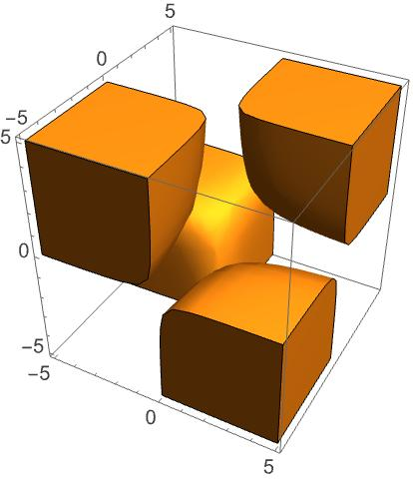

Connected region
# Source: AI Source: Provided by: [Data Path: Persons Table -> ID Column: 1, Name_En Column: Motasem Essam] -> From: [ChatGPT] on [7/25/2026]
A point inside the cube can be joined to any other interior point by a straight-line segment that remains inside the cube.
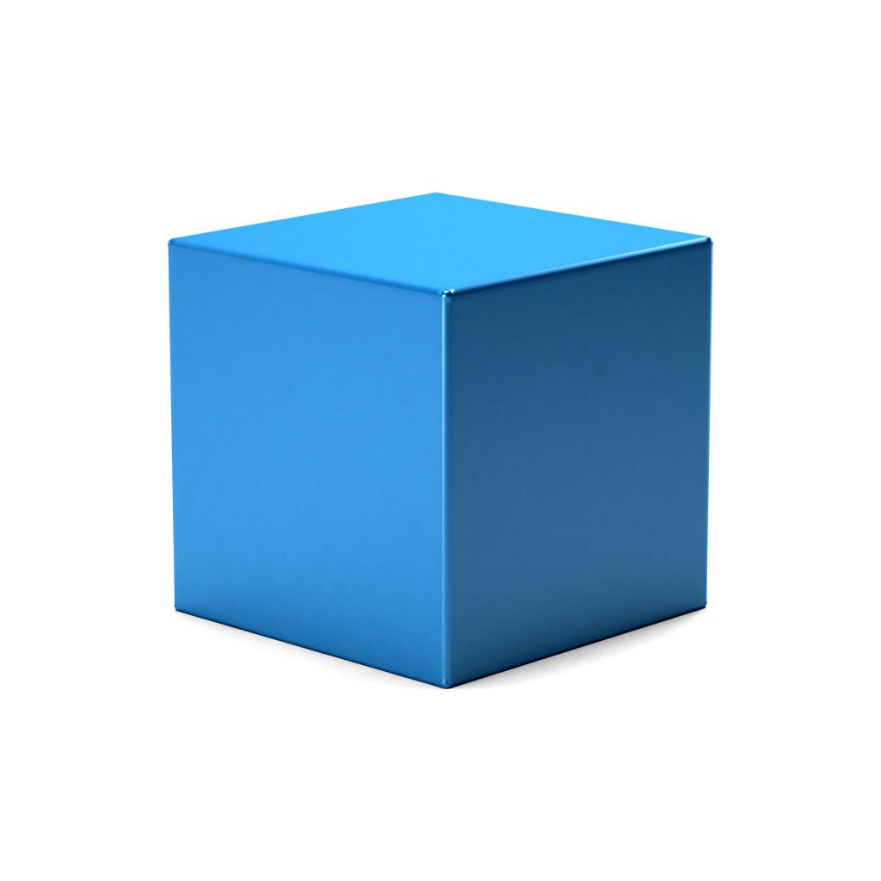

Disconnected region
# Source: AI Source: Provided by: [Data Path: Persons Table -> ID Column: 1, Name_En Column: Motasem Essam] -> From: [ChatGPT] on [7/25/2026]
If the two spheres are treated as one region, a path within the region cannot cross the gap between them.


Connected region with a narrow passage
# Source: AI Source: Provided by: [Data Path: Persons Table -> ID Column: 1, Name_En Column: Motasem Essam] -> From: [ChatGPT] on [7/25/2026]
Even if two larger parts are joined by a narrow bridge, the whole region is connected as long as the bridge provides a continuous connection.

Mathematical Representation

Connected region
# Source: AI Source: Provided by: [Data Path: Persons Table -> ID Column: 1, Name_En Column: Motasem Essam] -> From: [ChatGPT] on [7/25/2026]
A region $R$ is path-connected if, for any two points $P,Q∈R$, there exists a continuous path
$$γ:\left[0,1\right]→R$$
such that
$$γ\left(0\right)=P, γ\left(1\right)=Q$$
This means that a continuous journey from $P$ to $Q$ can be made without leaving the region.
Path-connectedness is a useful way to describe connected regions in many common solid-geometry examples. In general topology, connectedness and path-connectedness are distinct concepts, although they agree for many familiar geometric regions.

Disconnected region
# Source: AI Source: Provided by: [Data Path: Persons Table -> ID Column: 1, Name_En Column: Motasem Essam] -> From: [ChatGPT] on [7/25/2026]
A region $R$ is disconnected if it can be divided into two nonempty, disjoint subsets that are separated within $R$ and are both open relative to $R$.
Informally, the region has distinct parts with no continuous connection between them.
For example, consider two separate balls:
$$R=B_{1}∪B_{2}$$
where $B_{1}$ and $B_{2}$ are disjoint balls with a positive gap between them.
The union $R$ is disconnected because no path lying entirely in $R$ can join a point of $B_{1}$ to a point of $B_{2}$.

Example using coordinates
# Source: AI Source: Provided by: [Data Path: Persons Table -> ID Column: 1, Name_En Column: Motasem Essam] -> From: [ChatGPT] on [7/25/2026]
Consider the region
$$R_{1}=\left\{\left(x,y,z\right):x^{2}+y^{2}+z^{2}≤1\right\}$$
This is a closed unit ball. It is connected because every two points inside it can be joined by a straight-line segment that stays inside the ball.
Now consider
$$R_{2}=B\left(\left(-3,0,0\right),1\right)∪B\left(\left(3,0,0\right),1\right)$$
Here, $B\left(\left(a,b,c\right),1\right)$ denotes the open unit ball centered at $\left(a,b,c\right)$.
The two balls have centers six units apart and radii one unit each, so they are separated by a gap. Therefore, $R_{2}$ is disconnected.

Worked Examples
# Source: AI Source: Provided by: [Data Path: Persons Table -> ID Column: 1, Name_En Column: Motasem Essam] -> From: [ChatGPT] on [7/25/2026]
Example 1: Determine whether a cube's interior is connected
Suppose a cube occupies the region
$$R=\left\{\left(x,y,z\right):0<x<4, 0<y<4, 0<z<4\right\}$$
Consider two points $P=\left(1,1,1\right)$ and $Q=\left(3,3,3\right)$.
The straight-line segment joining them stays inside the cube's interior because every coordinate along the segment remains between $0$ and $4$.
Therefore, the region is connected.
Example 2: Determine whether two separate balls form a connected region
Suppose two closed balls have radius $1$ and centers at $\left(-3,0,0\right)$ and $\left(3,0,0\right)$.
The distance between their centers is
$$d=\sqrt{{\left(3-\left(-3\right)\right)}^{2}}=6$$
Their combined diameters are $1+1=2$, which is less than the distance between the centers. The balls are separated by a gap.
Therefore, their union is disconnected and has two connected components.
Example 3: A region with a narrow connecting passage
Imagine two large spherical chambers connected by a narrow solid tube.
Even if the tube is much smaller than either chamber, a continuous path can travel from one chamber through the tube into the other without leaving the region.
Therefore, the combined region is connected.
The width of the passage does not determine connectedness; the existence of a continuous connection does.
Example 4: A connected but unbounded region
Consider the half-space
$$R=\left\{\left(x,y,z\right):z≥0\right\}$$
The region extends infinitely far, so it is unbounded. However, any two points can be joined by a straight-line segment that remains in the half-space.
Therefore, it is connected and unbounded.

Comparison With Related Concepts
# Source: AI Source: Provided by: [Data Path: Persons Table -> ID Column: 1, Name_En Column: Motasem Essam] -> From: [ChatGPT] on [7/25/2026]
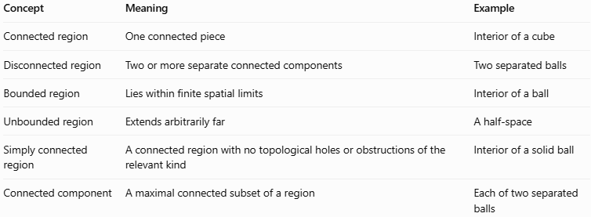
Concept | Meaning | Example
Connected region | One connected piece | Interior of a cube
Disconnected region | Two or more separate connected components | Two separated balls
Bounded region | Lies within finite spatial limits | Interior of a ball
Unbounded region | Extends arbitrarily far | A half-space
Simply connected region | A connected region with no topological holes or obstructions of the relevant kind | Interior of a solid ball
Connected component | A maximal connected subset of a region | Each of two separated balls
Connectedness and boundedness describe different properties. A region can be connected and bounded, connected and unbounded, disconnected and bounded, or disconnected and unbounded.

Applications
# Source: AI Source: Provided by: [Data Path: Persons Table -> ID Column: 1, Name_En Column: Motasem Essam] -> From: [ChatGPT] on [7/25/2026]
- Computer graphics: Determining whether a 3D model consists of one continuous object or separate pieces.
- Engineering: Checking whether components or material sections are physically connected.
- Robotics: Determining whether a robot can move between locations within a permitted region.
- Computational geometry: Identifying separate components in three-dimensional models.
- Physics: Studying connected material domains and spatial regions.
- Medical imaging: Identifying connected structures in reconstructed three-dimensional images.
- Topology: Studying the continuity and structure of geometric spaces.

Key Points
# Source: AI Source: Provided by: [Data Path: Persons Table -> ID Column: 1, Name_En Column: Motasem Essam] -> From: [ChatGPT] on [7/25/2026]
- A connected region forms one connected piece of space.
- A disconnected region consists of two or more separate connected components.
- In ordinary solid-geometry examples, connectedness can often be checked by finding continuous paths between points.
- A narrow passage can connect two large parts into one connected region.
- A gap between separate solids can make their union disconnected.
- Connectedness does not imply boundedness, and boundedness does not imply connectedness.
- Strictly speaking, a connected region need not always be path-connected in advanced topology; the two concepts coincide for many familiar geometric solids and regions.

Conclusion
# Source: AI Source: Provided by: [Data Path: Persons Table -> ID Column: 1, Name_En Column: Motasem Essam] -> From: [ChatGPT] on [7/25/2026]
Connected and disconnected regions in solid geometry describe whether points belong to one continuous spatial region or to separate components. This classification helps analyze three-dimensional shapes, spatial paths, solid models, and geometric structures. It is independent of whether the region is bounded or unbounded.

